|  |  |
| --- | --- |
|  |  |
|  | Foundation Activity 1 Conductivity and Breadboards |

Electricity

We can think of electricity like a rock slide:

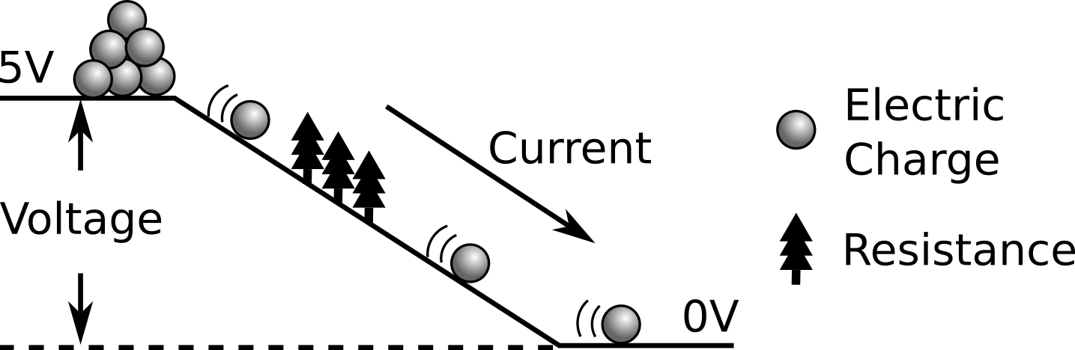

Conductivity: how easily electric charge can move in a material

|  |  |
| --- | --- |
| **Conductor** | **Insulator** |
| Electric charge moves easily. | Electric charge does not move. |

Testing the Conductivity of Different Materials

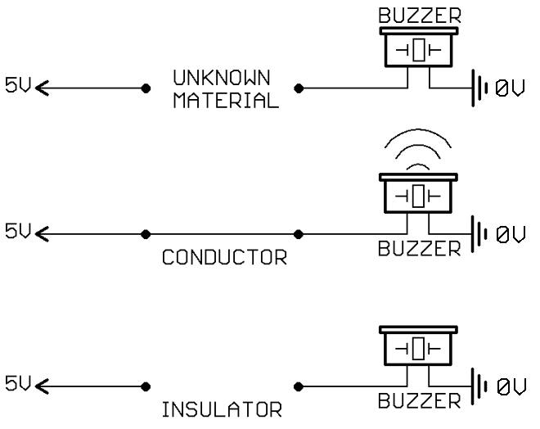

We can use this buzzer circuit to test the conductivity of different materials. If the material is a conductor, current will flow through it and the buzzer will sound. If it is an insulator, no current will flow and the buzzer will not sound. **Test** different materials around the room, and **fill in this table** with your observations.

|  |  |  |
| --- | --- | --- |
| **Material** | **Conductor** | **Insulator** |
| Metal wire |  |  |
| White-board |  |  |
| Pencil (wood) |  |  |
| Pencil (graphite) |  |  |
| Crayon |  |  |
| Coin |  |  |
| Paper clip |  |  |
| *Fill with other materials…* |  |  |
|  |  |  |
|  |  |  |
|  |  |  |
|  |  |  |
|  |  |  |
|  |  |  |
|  |  |  |

Mapping Conductivity on a Breadboard

|  |  |
| --- | --- |
| C:\Users\Harryp\MEGA\Surface Pro 2\Nepal\Himalayan Makers Guild\Activities\Activity 7 - Breadboard Basics\images\breadboard.png | Test which of the holes are connected and conduct electricity together. Draw lines across the holes to show which ones are connected. |

When multiple points are electrically connected, we call them a **node**.